Hannah E. Morse

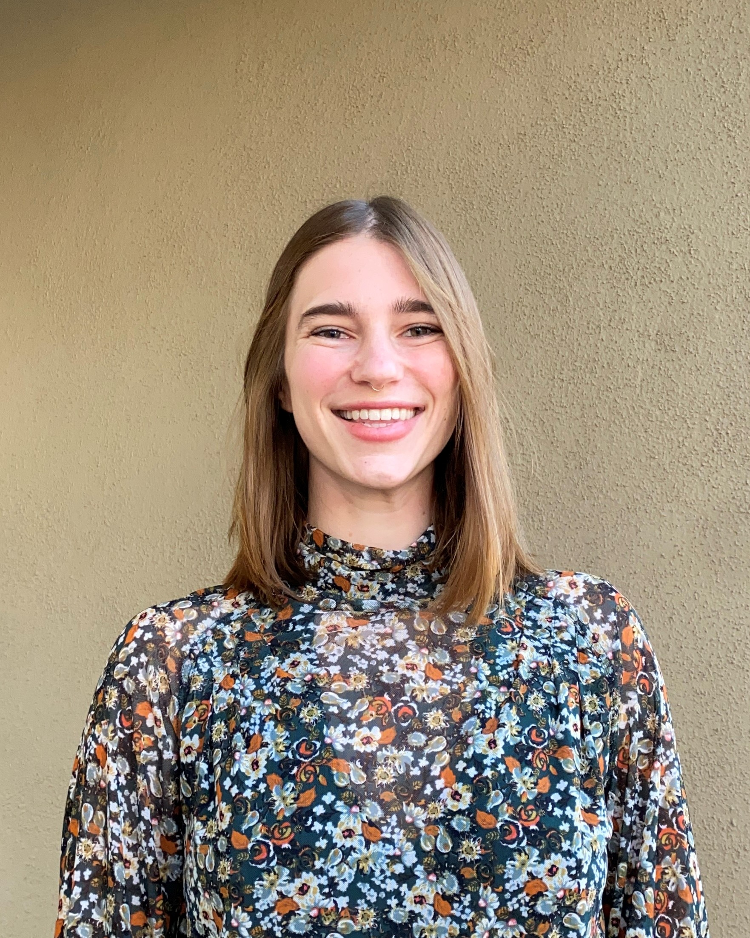

Hanna Morse

Education

BA – Environmental Studies, University of California, Santa Barbara, 2020

BA – Economics, University of California, Santa Barbara, 2019

Professional Experience

As a Technical Associate, Ms. Morse is responsible for providing environmental assessment, monitoring, sampling, inspection, research, data management, and design support services for SCS’s private and municipal clients. Her responsibilities include air quality permitting and compliance; greenhouse gas (GHG) emissions compliance; general regulatory compliance; and various permitting for solid waste and industrial facility projects.

Ms. Morse records data during fieldwork, including soil characteristics, groundwater or surface water data, meteorological conditions, compliance information, and waste characterization data. She provides summaries of visual observations through photographic and written field logs per standard operating procedures. She collects samples from hazardous and non-hazardous sites, including soil, air, surface water, groundwater, waste, and landfill gas.

Ms. Morse supports task managers in overseeing drilling activities involving probe and well installation, borehole logging, and well development, construction, monitoring, and sampling. She completes quality control reviews on work products (reports, design plans, calculations, data, etc.) before their submission, and coordinates with contractors, subcontractors, and clients as directed. She is fluent in English, German, and Spanish.

Her notable project experience is summarized below.

LCFS Fuel Pathway and Verification Services Project Experience

County of Santa Cruz, Landfill Gas Collection System Monitoring, Maintenance and Regulatory Compliance Engineering and Consulting Services, Santa Cruz, CA. As an Air Quality and Greenhouse Gas Specialist, Hannah was responsible for reviewing flare operational data, monitoring compliance with permit conditions, and completing semi-annual and annual Title V reports. She compiles data tables logging runtime, flow, methane, and more monthly for both flares at Buena Vista. The data analysis conducted by Hannah is utilized in the annual Landfill Methane Rule (LMR) and Greenhouse Gas reporting.

Forward Landfill, Landfill Gas Collection System Monitoring, Maintenance and Regulatory Compliance Engineering and Consulting Services, Manteca, CA. As an Air Quality and Greenhouse Gas Specialist, Hannah completes all required reporting including annual and semi-annual Title V Reports, LMR reports, and GHG reports. Hannah provides non-routine support it items such as permitting, violation responses, district data requests, and more. Hannah monitors the GCCS to create startup, shutdown, and malfunction logs, and document compliance with permit conditions.

Phillips 66, Verification of GHG Emissions Data Report, Wilmington, CA. In the role of Verifier-in-Training, Hannah verified client data by examining shipment receipts, inventory, meter calibrations, and feed analysis to confirm that the pathway calculator was accurately completed. She noted discrepancies between her findings and the client’s submitted pathway and calculated the percent variation in the data to substantiate that the difference was negligible. For this project, she submitted her conclusions to her supervisor for inclusion in the validation report.

ACT Commodities, Low-Carbon Fuel Standards (LCFS) Pathway Validation, New York, NY. As Verifier-in-Training, Ms. Morse assisted in compiling relevant information into a sampling plan. She verified client data in the Pathway Validation Calculator by examining electricity bills, meter calibrations, Liquefied Natural Gas (LNG) production, and injection receipts. She noted discrepancies between her findings and the client’s submitted pathway and communicated with the client to understand and resolve divergences between calculator inputs and reported data. After confirming that the pathway calculator included all appropriate data and information, she provided support in the completion and submission of the validation report, which included data analysis, validation findings, and conformance evaluation.